

Template Mental Health and Well-Being Strategy

1.0 Introduction - What is mental health and well-being;
The correct way to view mental health is that we all have it and we fluctuate between thriving, struggling and being ill and possibly off work. People with poor mental health including common mental health problems and severe mental illness can be in any of these groups. An individual can have a serious mental health problem but – with the right support – can still be thriving at work. Equally someone without mental health issues, can experience poor mental health if they experience high levels of stress. We all have different levels of mental well-being, and at different times we may move in and out of different levels of mental wellbeing (between good and bad mental wellness), depending on our current situation, personal and environmental stress levels that we are experiencing.
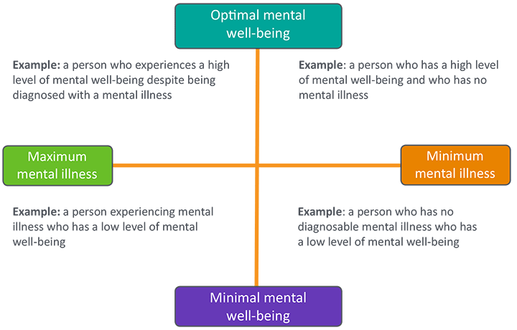

As the above diagram shows and individual may move between the quadrants and does not have to have a mental health condition to have low mental well-being; this can be caused by stress in the workplace. Equally an individual may have a mental health condition and with the right support and appropriate adjustments can have high mental well-being.
Everyone has mental well-being good or bad and experiences different levels of mental well-being at different times throughout their life, without having to have a mental health illness. Therefore, everyone should take steps to secure their own mental wellness and that of those around them albeit at work, at home or in the community.

As an employer we need to be aware of this and ensure that the organisation and culture within fosters positive mental health and well-being. We need to support employees who suffer with negative mental health to allow them to move into optimal well-being and to ensure that those not suffering with negative mental health stay at optimal well-being.

(Company Name) is taking steps to improve and protect the mental health and well-being of its employees. We are working on creating a culture to foster positive mental health and well-being by educating and equipping all managers. We are also taking active steps to reduce stress in the workplace.

2.0 Reasons for the strategy and legal obligations / and Why it is important to have good mental health and well being strategies in the workplace /
2.1 Section 2 (e) Health and Safety at Work At 1974 defines the general duties of care of an employer to his staff and paragraph around well-being at work.
The provision and maintenance of a working environment for his employees that is, so far as is reasonably practicable, safe, without risks to health, and adequate as regards facilities and arrangements for their welfare at work.

2.2 A recent sea change is evident in how stress in the workplace is enforced by the Health and Safety Executive (HSE) as the enforcing body and connecting it with workplace incidents notified to them. Mental health issues including mental illness are now regarded as one of the most significant issues in the workplace in Britain. Recent research has assessed that one in three workers is impacted by problems connected with mental health. The financial cost is estimated by the Mental Health Foundation in the UK as £225 billion (yes billion) per year. If staff are off sick this is obviously costly to the organisation, but there is also the human cost associated with this.

3.0 Recognising and reducing stress in the workplace

The workplace is a shared and important environment for us all , however, our actions – or lack of action can have an adverse effect on others that we don’t consider because we don’t know . We should be aware of this in our workplace as we all carry a shared responsibility
The effects in the workplace can spill out into people’s personal life and can have a negative effect not just on them but those around them.
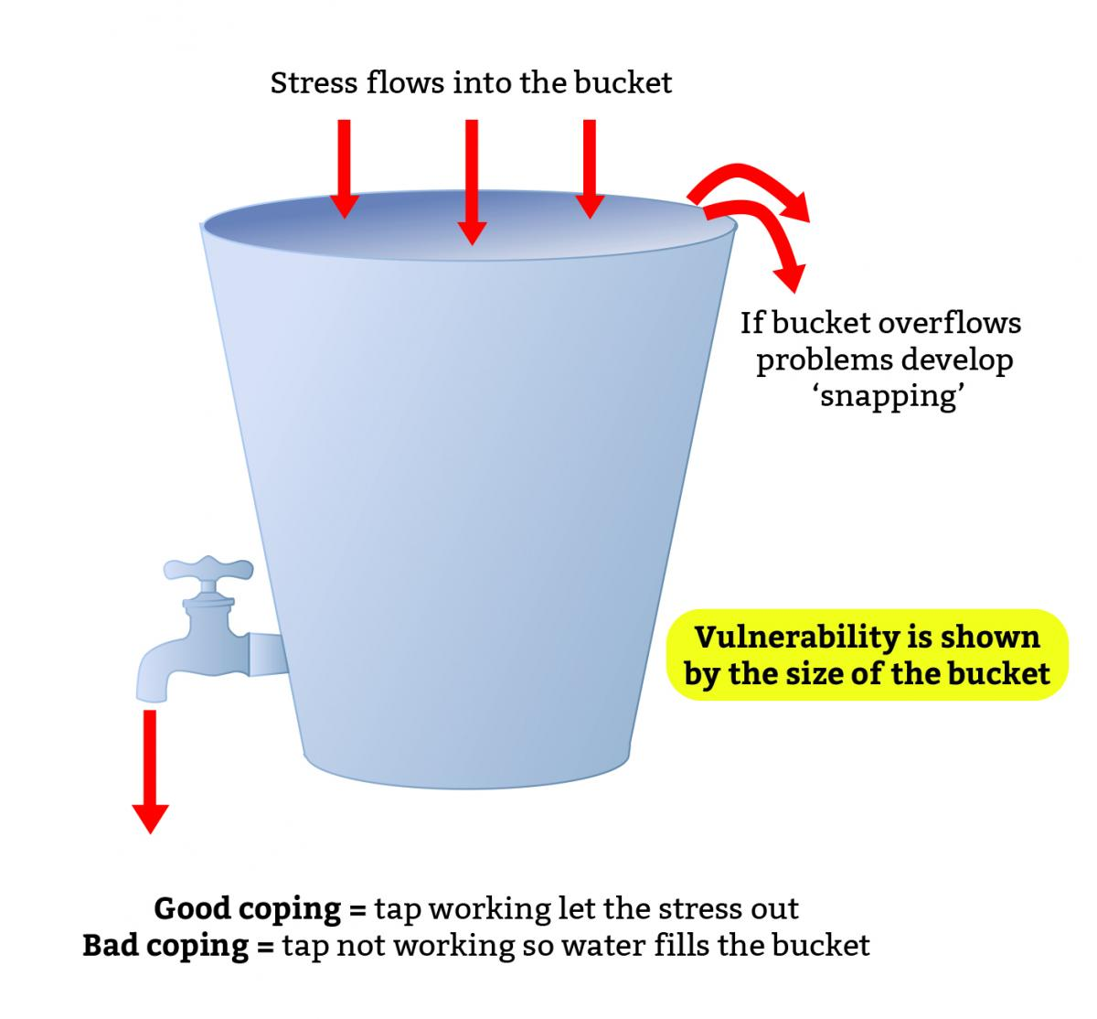

4.0 An awareness of employee’s individuality and individual needs

The frame of reference is the term used by Jacqui and Aaron Schiff to refer to our individual filter on reality.

They defined the frame of reference as: “The structure of associate responses which provide the individual with an overall perceptual, conceptual, affective and action set, which is used to define the self, other people and the world”.

Our individual frame of reference is influenced by a range of factors from our upbringing and experience. These include our family situation, education, culture and life experiences.

This highlights how stress is subjective, and everyone reacts differently. Individuals may experience more stress / be less able to cope with stress in the work place based on other events happening outside of work (i.e. if they are experiencing problems in their home life) and based on their past experience i.e. if they have been bullied in the workplace in the past. The bottom line is - Stress is subjective, everyone's perspective and ability to cope with stress is different and we need to be mindful of this. Therefore this policy aims to reflect this by developing a range of approaches to address mental health and well-being in a variety of ways.

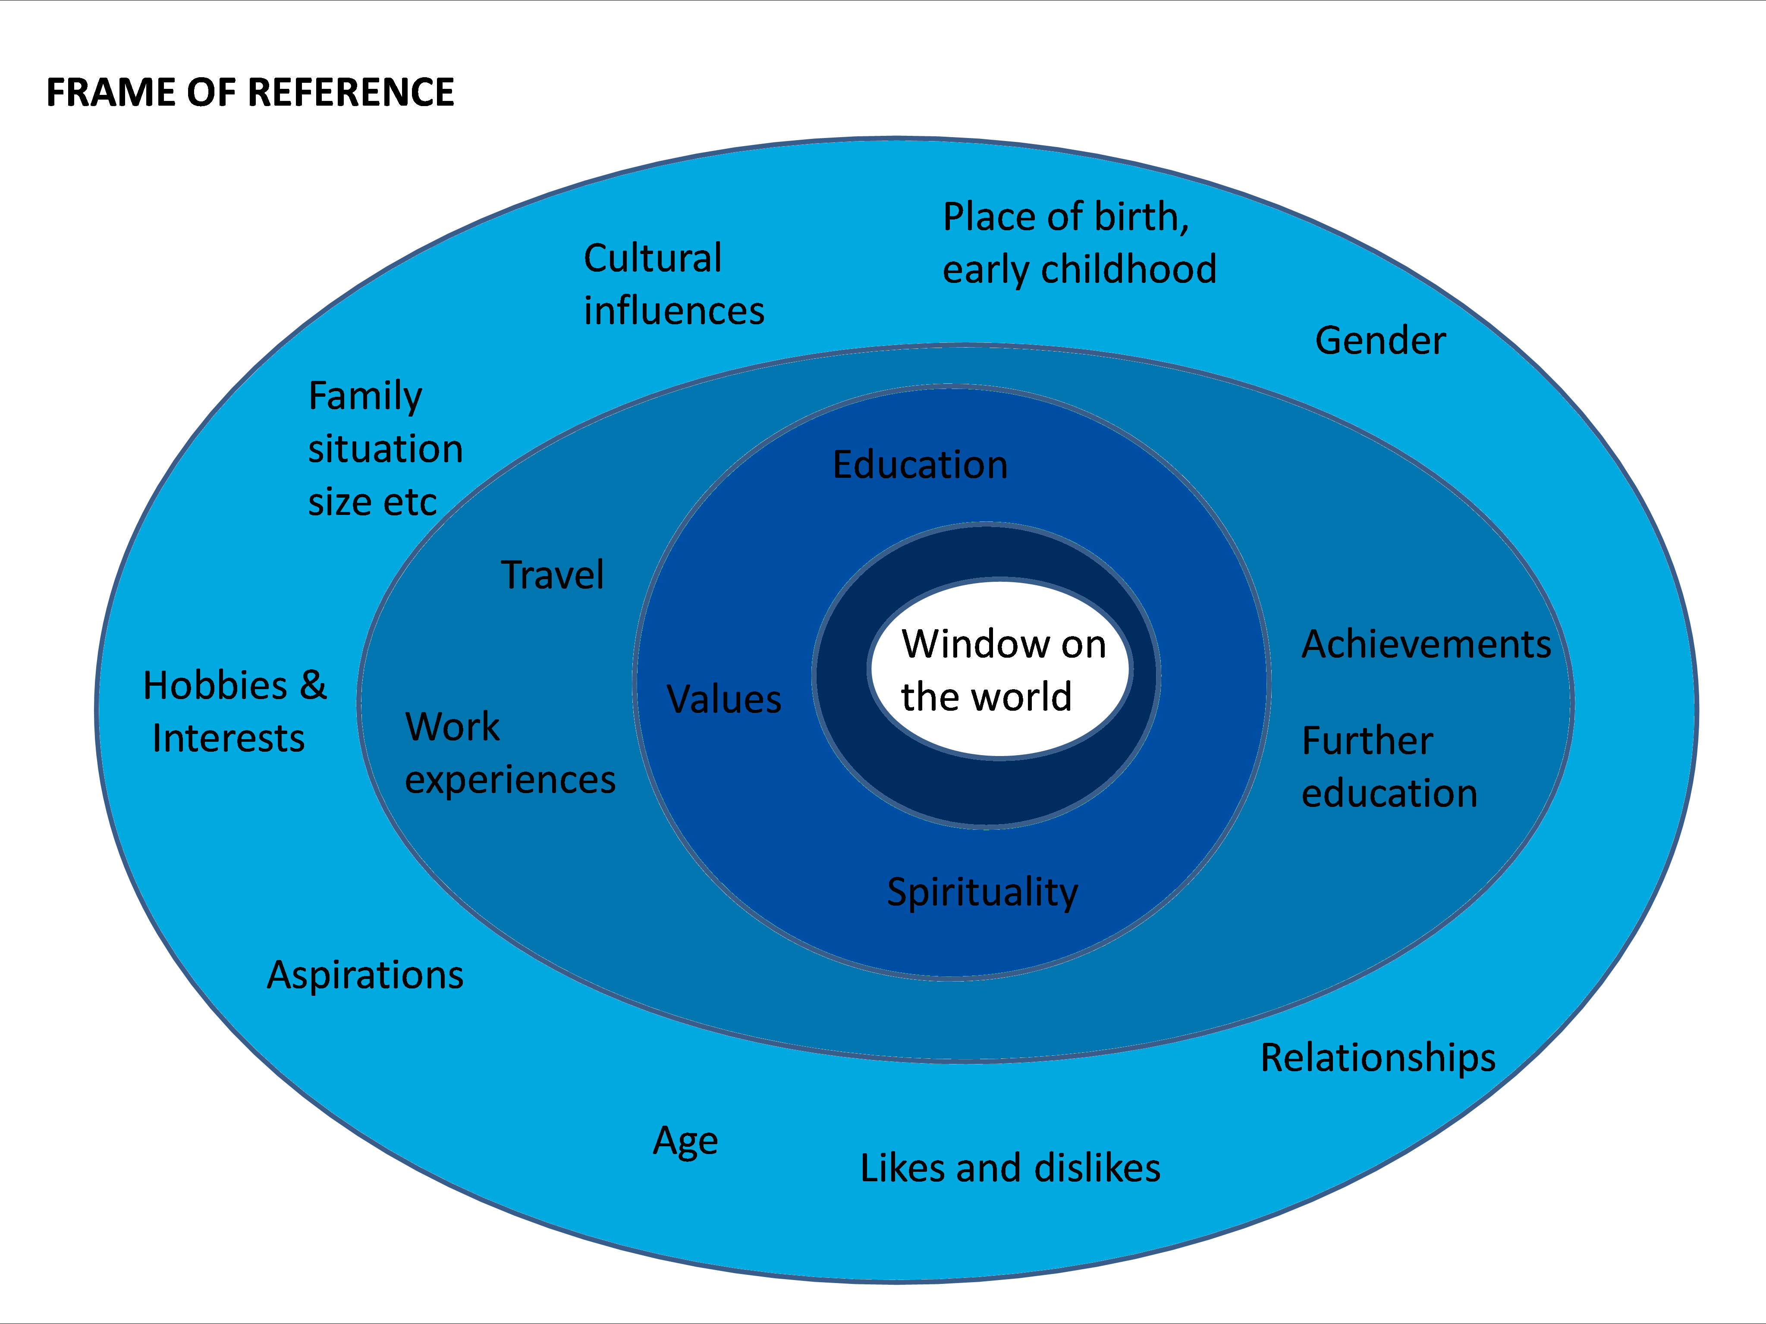

5.0 Recognition of issues whilst working in the Community / Safeguarding
Purely by the nature of our business we may come into contact with service users in the community who may have mental health issues. This strategy will contribute to how (COMPANY NAME) LTD can approach such situations in an appropriate and consistent way so that (COMPANY NAME) xxxx employees are able to report safeguarding issues, and that staff will be supported where appropriate during this process.

We also ensure that employees have protection whilst they undertake their normal duties, this is in the form of lone working devices, dynamic risk assessments, PPE and diary management. This allows operatives to perform their duty without additional undue risks and stresses.

6.0 The role of the strategy
6.1 Aims
- Take steps to ensure that we don’t overload staff with work and place them under stress and that we;
- recognise when people are stressed and act to help to reduce their stress levels.

6.2 Objectives

The role of this strategy is to;
- Create an open culture where staff can discuss issues with their managers.
- Make reasonable adjustments, where possible, for staff suffering from stress or reporting to have mental health issues, with the support of occupational health, HR and the health and safety advisors as appropriate.
- As well as looking after our employees whilst they are at work in line with our responsibilities under H&S legislation, we also have a duty of care to ensure that the public are not impacted negatively by the undertaking of our business activities.
- Ensure a consistent approach to mental health and well-being across the company.
- Identify appropriate elements contained within the “Stevenson Farmer review “which may be appropriate for (COMPANY NAME) LTD to apply within the workplace ‘core standards’ (see below).

7.0 Our Mental Health core standards:

7.1 Produce, implement and communicate a mental health at work plan;

We have a mental health plan which outlines our approach to improving and protecting the mental health of all employees, this consists of holding x well-being days a year, regularly awareness presentations on mental health and well-being, mindfulness sessions for all staff and a counselling session for all staff (employee assist programme).

We also have mental health first aiders and mental health champions within the organisation.

xxxxx

This policy is also linked the Health and Safety Strategy and The Management of Absence Policy.

  - Develop mental health awareness among employees;

We know that employee awareness of mental health, including for line managers and supervisors, will encourage individuals to care for themselves and help them to provide support to others. In order to address this, we hold staff well-being days which are a ‘spot light on well-being’. There is also a regular slot in the monthly staff newsletter that goes out to all employees. We also have mental health first aiders and mental health champions within the organisation and run regular presentations on mental health and well-being.

  - Encourage open conversations about mental health and the support available when employees are struggling;

xxxxxxxxxxxxxxxxxxxxxxx

  - Provide employees with good working conditions and ensure they have a healthy work life balance and opportunities for development;

xxxxxxxxxxxxxxxxxxxxxxxxxx

  - Promote effective people management through line managers and supervisors;

We know that effective people management at all levels is crucial for supporting the mental health of all employees and as such we monitor and measure staff sickness to enable the early identification of potential wellbeing issues, allowing for prompt remedial action to be taken.
We ensure that the right support is in place to assist managers to manager people, with the support of HR and H&S to understand and support employees with any stress related and MH issues via the management of employee process(s).

We have visible senior management commitment, a senior manager xxxxxxxxxxxxxxxxxxxxxxxxxxxxx

  - Routinely monitor employee mental health and wellbeing.

We are taking steps to recognise when stress is an issue; We will review sickness absence data, return to work forms and other data which can be used to spot problems and focus any support, in collaboration with HR and H&S to understand and support employees with any MH issues identified through the management of employee process(s).

The business will ensure that managers are supported in managing their people, applying tools such as 1-2-1 and taking relevant actions where MH issues are identified.

- Measures
  - To train up xxx members of staff as mental health first aiders
  - To have at least one mental health & well-being champion in each department
  - To have at least 10 articles on mental health and well-being in the staff newsletter per year.
  - To conduct at least 6 mental health and well-being presentations per year.
  - To have at least 2 wellbeing days a year
  - To offer discounted gym membership to all staff
  - To offer one lunch time yoga class per week, which all staff members can sign up to

- Reviews
This strategy will be reviewed on an annual basis or sooner following significant change to ensure that it remains fit for purpose.

